Argomento numero 2 di Lingua Inglese

A Few Hints on Romanticism in English Painting
Informazioni generali sul Romanticismo nella pittura inglese in lingua inglese.
Dopo aver letto il testo gli studenti eseguono le attività proposte.
Attraverso queste attività dovranno esprimersi in lingua inglese e raccontare anche fatti e conoscenze personali.
All’interno delle competenze linguistico-comunicative, si valuterà soprattutto il successo ottenuto nella trasmissione di pensieri e di idee, anche se non sempre corrette dal punto di vista formale.

READING ACTIVITY

A few hints on…..
….Romanticism in English painting
Romanticism in art, as well as in music and literature, was opposed to reason, order and harmony which were the key ideas of the Age of Reason.
The Romantics reasserted the autonomy of the individual and the primacy of imagination, unrestrained intuition, emotion and feeling.
Landscape was the most characteristic achievement of English Romantic art and the British landscape became synonymous of British freedom.
John Constable (1776-1837) and William Turner (1775-1851) were the two major landscape painters of the 19th century.
Constable’s deep love for countryside and nature is evident in all his work. Unlike Turner, he rarely travelled, and even then only between the British isles. His cloud studies and rural scenes were the culmination of English painting of landscape art.
Thanks to his highly sophisticated watercolour technique he was able to present immense spaces and panoramic views seen in all kinds of atmospheric conditions.
Although very different in style and content, the paintings of Turner and Constable developed a freedom of paint handling that was to have a profound effect on landscape art.
The moods of nature from the range of greens in Constable’s meadows under windy, cloudy skies to the grey misty blues and brown snowstorms in Turner’s Alps or rain-lashed seas, were expressed through free brushes strokes.
They both used watercolour for preliminary sketches and studies as well as for finished works, however they are best known for the later oil paintings (i.e. The Shipwreck, The Vale of Dedham).
They were both prolific artists and left behind hundreds of drawings, sketchbooks and finished paintings.

AFTER READING:
- What do we mean when we say that a person is’ romantic’?
- Do you consider yourself ‘romantic’? if so, why?
- Here you have learnt about two famous Romantic English painters. Name two famous Romantic English novelists and tell the class, include the titles of some novels.

Loneliness in Constable, Fontanesi and Banksy

- 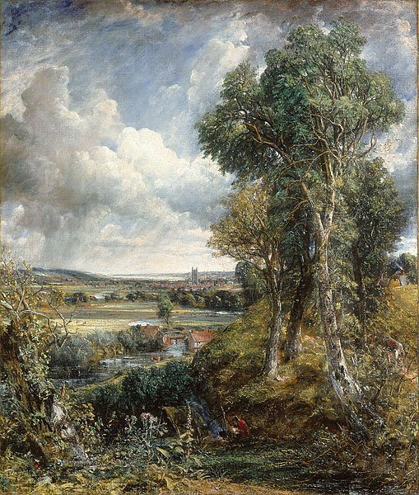
- John Constable- The Vale of Dedham -1828 (Scottish National Gallery- Edinburgh)

- Constable painted two versions of this “The Vale of Dedham”; in addition to the one painted in 1802, at the bottom of this painting he added a gipsy mother nursing her baby.

- 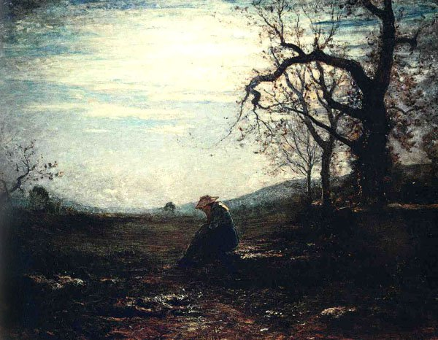
- Antonio Fontanesi (1818-1882) La Solitudine (Musei Civici di Reggio Emilia)

- Italian painter born in Reggio Emilia, known for his works in the romantic style of the French Barbizon school (influenced by Constable’s rural scenes, in its turn). “La Solitudine” shows a rural landscape where a lone shepherdess is deeply immersed in her thoughts. Loneliness, one of Fontanesi’s favourite themes, is the best feeling to live an intimate relationship with nature which is majestic but at the same time very far, and thus allows a dialogue full of silences and hopes.

- 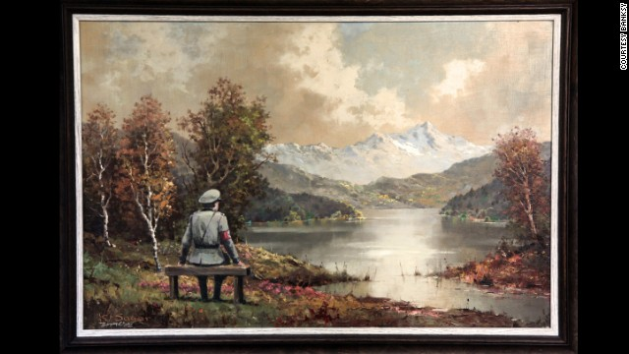
- Banksy (1974-present)- The Banality of the Banality of Evil

- Banksy, whose real name is unknown, is an English street artist. He is a graffiti master as well as a painter, an activist, a film maker and an all-purpose provocateur. This work depicts a man in Nazi uniform contemplating a lake and snowy mountains from a wooden bench.

Analyze the three paintings and …..

- Find out at least four similarities
- Which kind of feelings do the three paintings excite in you?
- Is loneliness a status associated with a specific age of our life?
- The third painting is from a contemporary author. Does it differ from the others? If so, in what?
- Are there any significant examples of street art in your home city? If so, what is the message that they tend to transmit? Give examples.

'Writing stories collaboratively'

Students, in groups of 3/4 are given images of paintings and their task is to write stories collaboratively. Each team must write one paragraph based on the painting in question. Then the text is sent to another group and continued. This group has another painting to look at .

